Name: Thabiso
Surname: Matsaba
Student Number: 220296006
Course: Applications Development Theory 2
Course Code: ADT26S2
Assignment 2: Food Parcel Management System (FPMS)
Lecturer: Mrs E Zietsman
Due Date: 12 August 2021

THE DESIGN OF A FOOD PARCEL MANAGEMENT SYSTEM

Prepared for
Mrs E Zietsman and Mr A Afolayan
Cape Peninsula University of Technology

Prepared by
Thabiso Matsaba

August 12, 2021

TABLE OF CONTENTS
Page

TABLE OF CONTENTS……............................................................................... i
LIST OF FIGURES…………………………………………………………........ ii
SECTION 1…………………………………………………………………….... 1
Introduction……………………………………………………………………….. 1
User Stories…………………………………………....…………………………. 1
…………………………………………………………......................................... 2
SECTION 2……………………………………………………………………...... 2
Use Case Diagram…………………………………………………………………. 2
SECTION 3.............................................................................................................. 3
Domain Model Class Diagram.................................................................................. 3
SECTION 4............................................................................................................... 4
Activity Diagrams..................................................................................................... 4
……………………………………………………………………………………… 5
……………………………………………………………………………………… 6

LIST OF FIGURES
Figure Page
- Use Case Diagram………………………………………………… 2
- Domain Model Class Diagram…………………………………… 3
- Activity Diagram 1…………………………………………………. 4
- Activity Diagram 2…………………………………………………. 5
- Activity Diagram 3…………………………………………………. 6

Section 1
Introduction
In my report, I will be addressing the design of a food parcel management system of a non-governmental organisation called Foodforward SA. In my previous report, I identified the functional requirements needed to design the system for the organisation. In this follow up report, I will focus on the user stories, use case diagram, activity diagram and domain class diagrams of the system for the organisation.
NGO = Foodfoward SA
User Story
- As a manager, I want to be able to login in the system so I can be sure data will be protected and secure.
Acceptance Criteria
- A sign-up or login page must be present when accessing the site.
- An account verification message must be included either by email or phone number.
User Story
- As a manager, I want to be able to track food parcel inventory so I can be able to make changes to the system.
Acceptance Criteria
- Sort the items in the inventory alphabetically.
- Enable updates by indicating the available food items in stock and out of stock.
User Story
- As a user, I want to be able to make money transfers online so that I can donate it quickly and easily.
Acceptance Criteria
- An option to pay fees via EFT, Mastercard and Visa should be available to the user.
- A history of the balance must be displayed to the user.
User Story
- As a user, I want to be able to track food parcels so I can know when they will be delivered.
Acceptance Criteria
- A user can place an order at any time, 24 hours per day.
- A user may cancel the order at any time prior to delivery.
Section 2
- Use Case Diagram for Foodfoward SA System
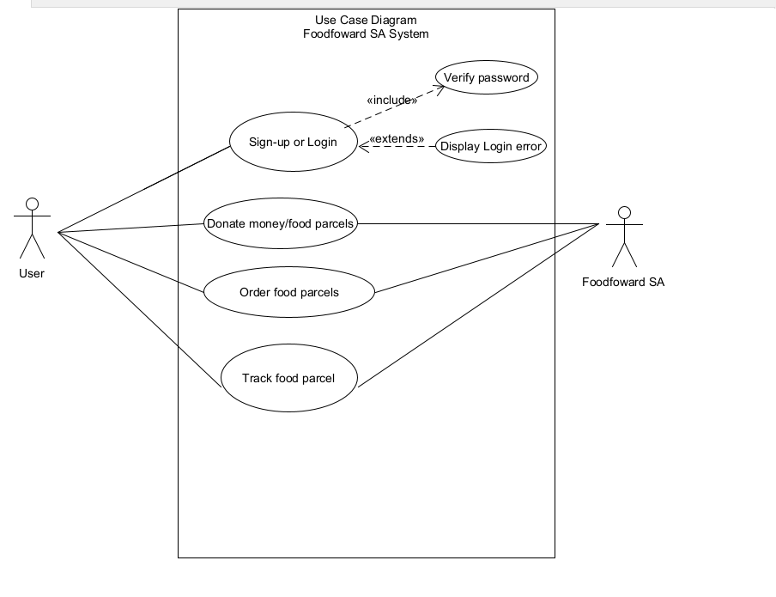
Figure 1: Use Case Diagram

Section 3
Domain Class Model Diagram
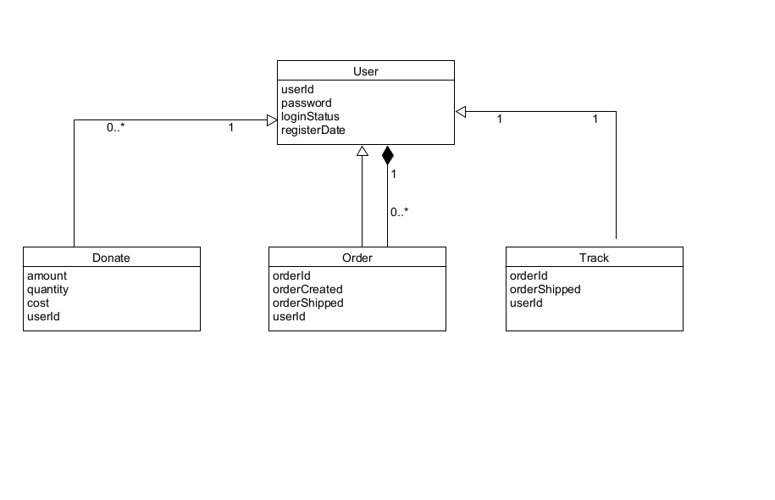
Figure 2: Domain Model Class Diagram

Section 4
Activity Diagrams for Fuctional Requirements
- Activity Diagram for Users to Sign-up and Login
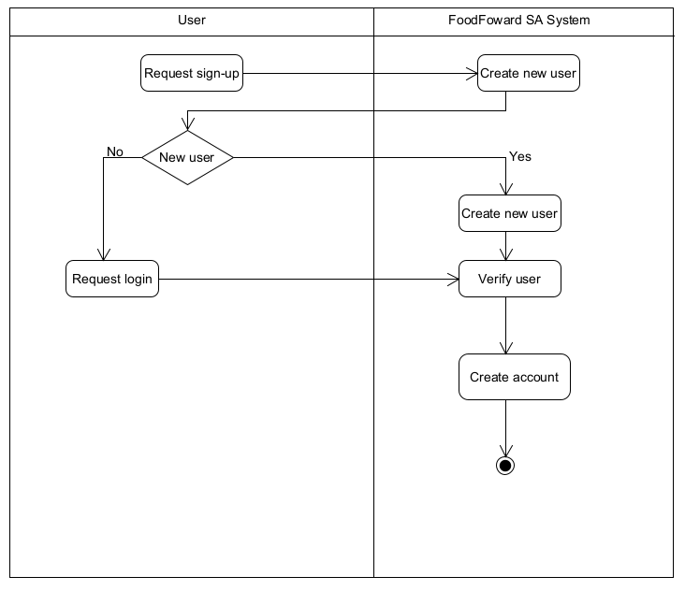
Figure 2: Activity Class Diagram 1

- Activity Diagram for Users to Order Food Parcels
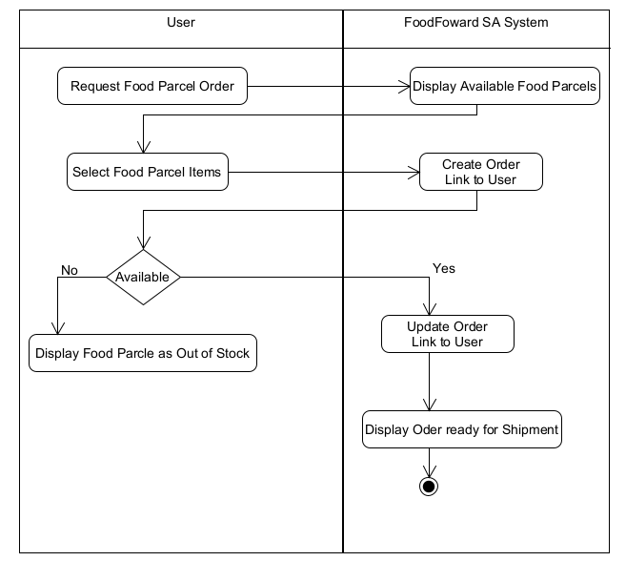
Figure 2: Activity Class Diagram 2

- Activity Diagram for Users to Donate Food Parcles
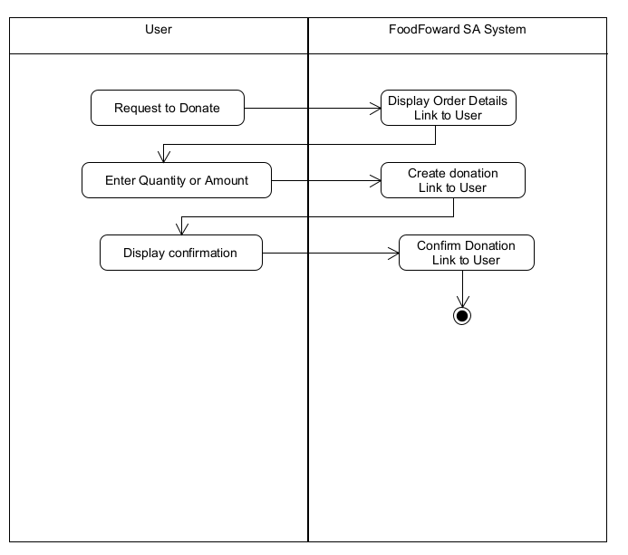
Figure 3: Activity Class Diagram 3

